Press information
For immediate release
2026-10-21

Qtagg brings next-generation propulsion and power control to Fred. Olsen Cruise Lines’ flagship Bolette
Qtagg completed a major propulsion control upgrade on Fred. Olsen Cruise Lines’ flagship Bolette, replacing the DEGO III engine governor with the latest DEGO IV platform. The upgrade gives the vessel more precise propulsion control and significantly greater visibility into system performance, while adding advanced diagnostics and remote support capabilities.
Digital propulsion control for efficiency and precision
DEGO IV builds on the proven DEGO platform with a connected digital architecture that allows the control system to control engines more effectively and respond rapidly to changing operating conditions.
For the crew, the upgrade also means significantly greater visibility. Digitalized propulsion control translates into real-time information, performance trends and detailed logging that make it easier to understand how the system is performing.
Precise control across changing operating conditions
DEGO IV continuously adapts its control to different engine speeds and loads, helping keep the propulsion engines at the required speed while operating within safe limits. This provides precise and responsive engine control across a wide range of operating conditions.
Together with the upgraded actuator system, DEGO IV provides accurate control of the fuel rack and responds quickly as propulsion demands change. High-frequency logging and real-time operating data also give engineers greater insight into engine and propulsion system performance, supporting more effective tuning and troubleshooting.
For Bolette, the result is a propulsion control system that combines precise engine control with better visibility and greater opportunities to optimize performance.
Designed for a straightforward transition
DEGO IV has the same physical size and electrical interface as DEGO III, making it possible to retain much of the existing installation while moving to the new platform.
This provides a practical upgrade path for other operators who want access to modern control, monitoring and optimization capabilities without replacing the entire installation.
Faster commissioning and smarter diagnostics
DegoAid simplifies commissioning and service of DEGO IV by bringing configuration, tuning, monitoring and diagnostics into one engineering tool. High-frequency operational data allows engineers to see how the governor responds to rapid changes, making it easier to optimize performance and identify problems that slower monitoring can miss. Configuration data can also be stored and reused, supporting faster commissioning and more efficient long-term service.
Investing in continued performance
Bolette is the flagship of Fred. Olsen Cruise Lines and carries up to 1,273 guests. The upgrade is part of the cruise line’s continued investment in the performance and reliability of its onboard systems.
“We continuously review opportunities to improve our onboard systems where they support reliability, safety and the guest experience,” says Håvard Næss, Senior Superintendent at Fred Olsen Cruise Lines. “The DEGO IV upgrade gives Bolette a modern platform that supports the high standards we expect from our vessels.
About Bolette
Vessel type: Cruise ship
Gross tonnage: 62,735
Length: 238 m
Beam: 32 m
Capacity: 1,273 passengers
Year built: 2000
About Fred. Olsen

Fred. Olsen Cruise Lines is a UK-based cruise operator with Norwegian maritime heritage dating back to 1848. Based in Ipswich, Suffolk, the company operates cruises from the UK and Grand Voyages aboard a fleet of smaller ocean-going ships: Bolette, Borealis and Balmoral. Fred. Olsen Cruise Lines is known for its smaller-ship cruising approach, offering carefully planned itineraries designed to bring guests closer to destinations, including ports and waterways that are less accessible to larger vessels. The company is part of the wider Fred. Olsen group, which has interests across travel, leisure, logistics, renewable energy and other sectors.
About Qtagg
Qtagg is a Swedish company that develops advanced control systems for the marine industry. The company focuses on energy optimization and automation for propulsion and power systems used on commercial vessels. Its main goal is to help shipowners reduce fuel consumption and emissions while improving operational efficiency and reliability.
www.qtagg.com

For more information, please contact:
Per Österberg, Chief Commercial Officer, Qtagg
per.osterberg@qtagg.com
+46 73 301 91 00
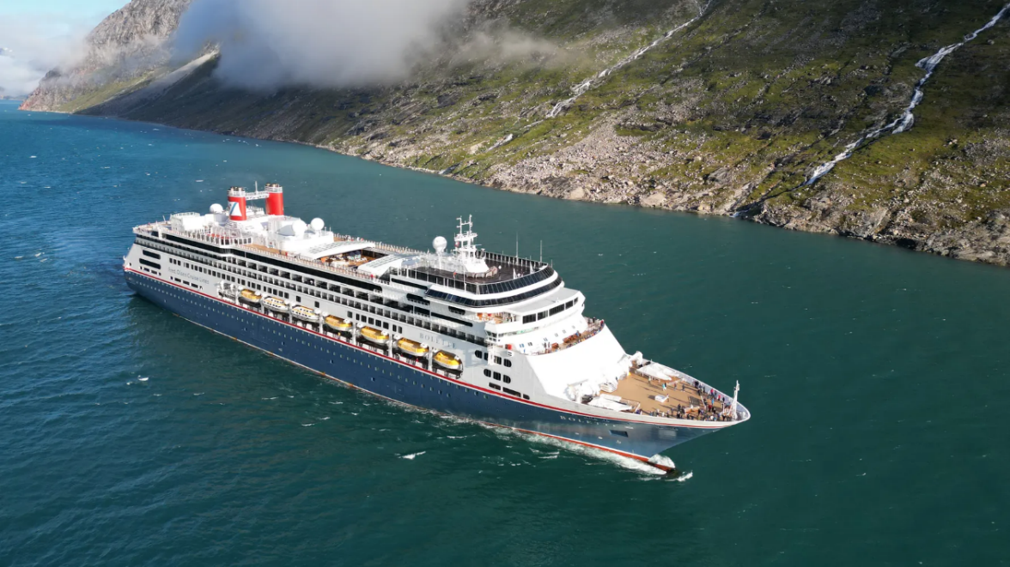
The Bolette cruise ship has gotten an upgrade from analog to digital propulsion control with a simple retrofit.
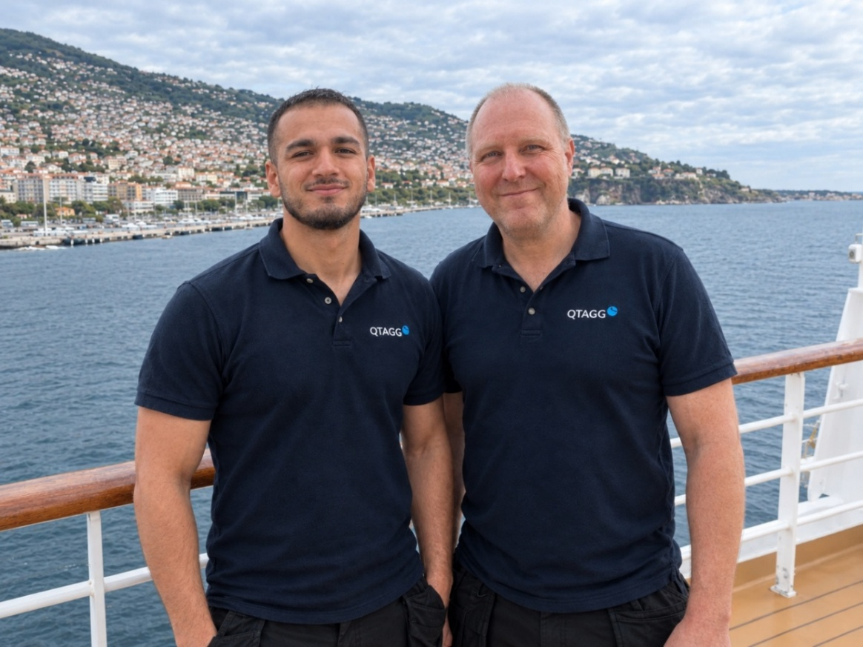
David Aldana and Tomas Lindqvist from Qtagg onboard Bolette.
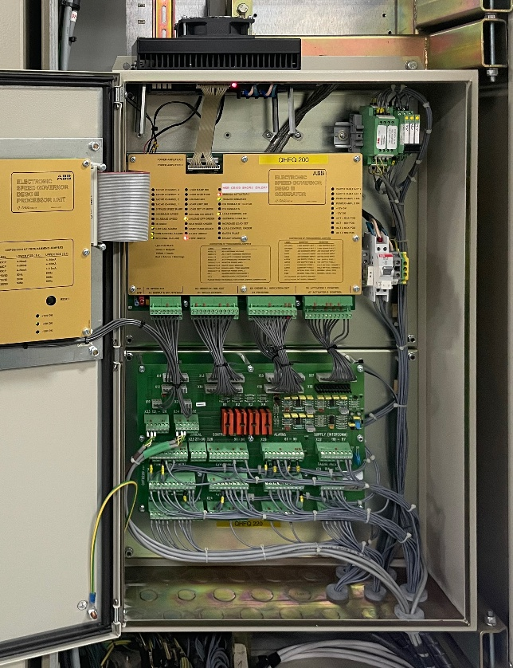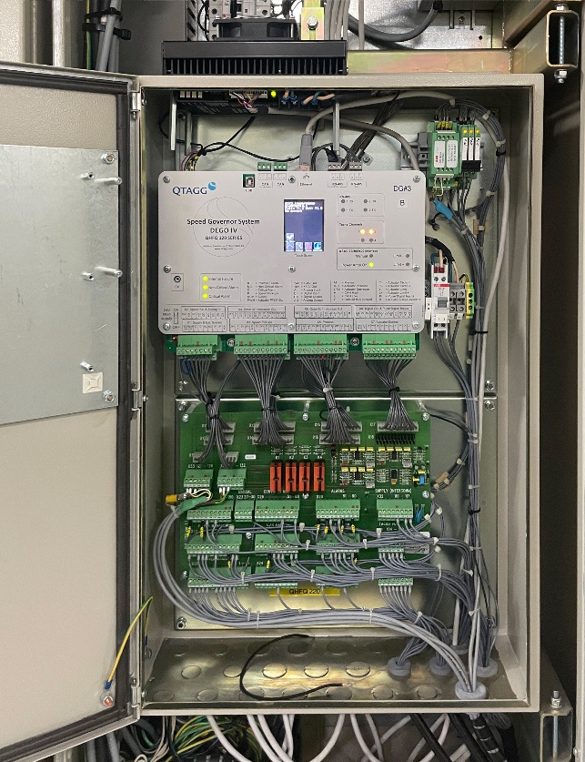
The governor cabinet before and after the retrofit DEGO III to DEGO IV.
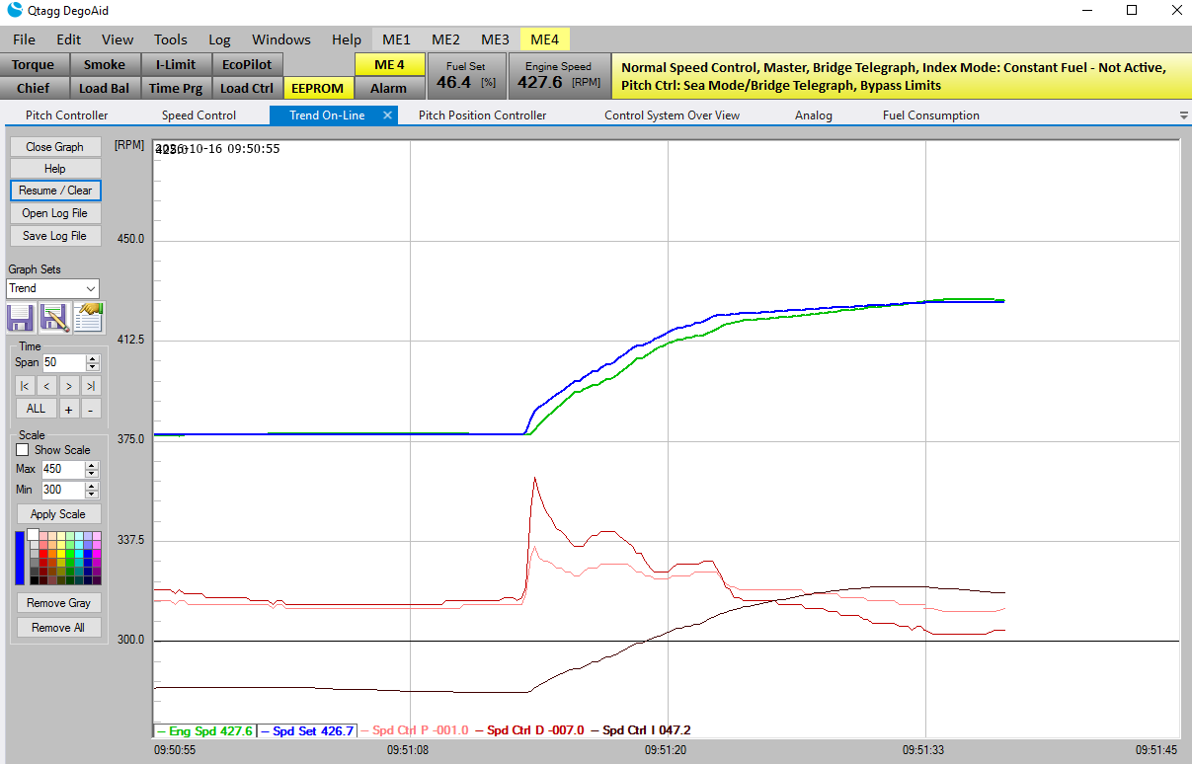
DegoAid shows the DEGO IV governor and its live operating signals in one view.
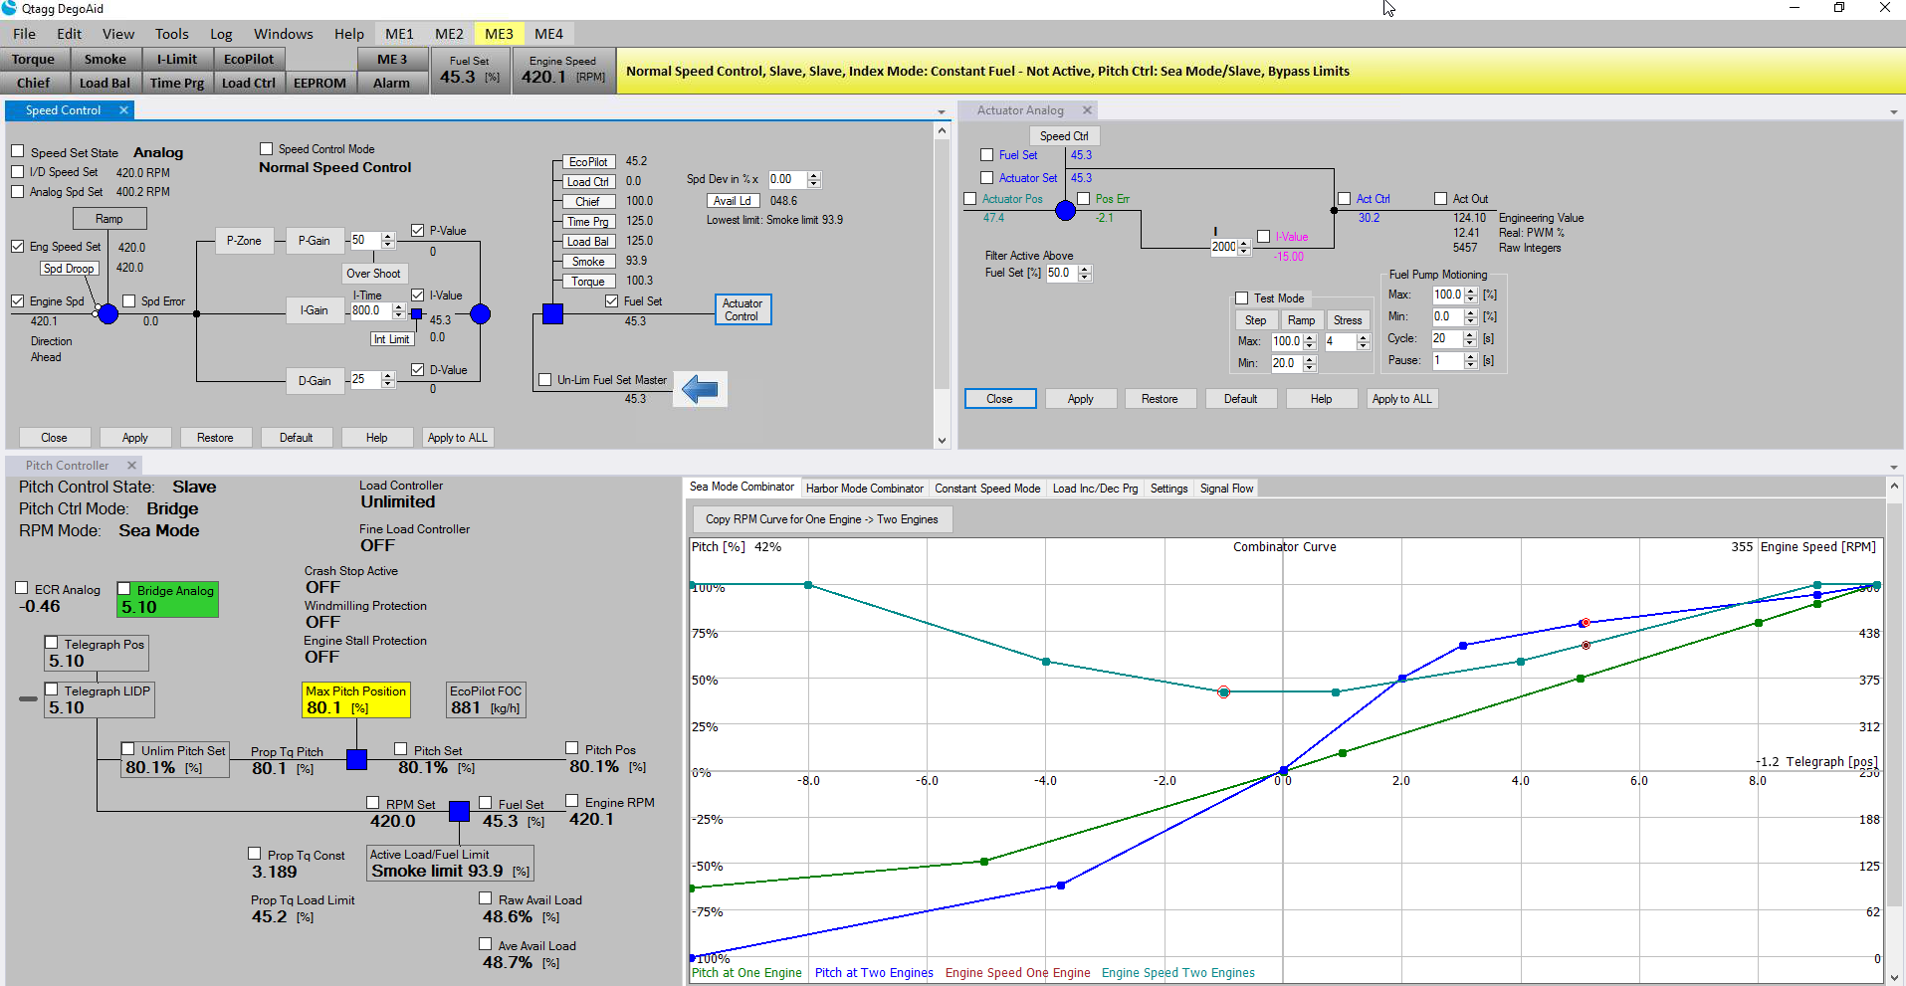
High-frequency data shows how the DEGO IV governor responds while it is being tuned.

